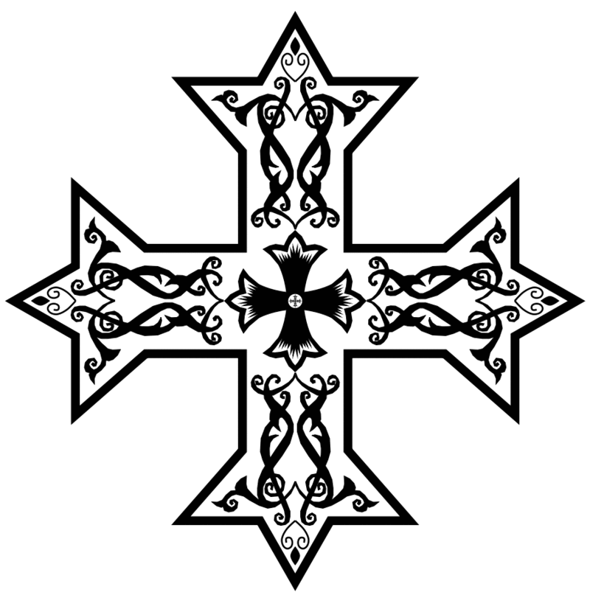
2016 – 2017 Arepsaline School 7th & 8th Grade Hymns
Psalm 150 During Communion in Kiahk

Pijen-misi emparse-nikon owoh ni-nak-he, emep-nevma-tikon o eshfe-ree empara-zoxon kata ni esmee emep-rofee-teekon.
Shere vethleem petlos eniprofetees thietavmes pikhristos enkhits pimah esnav enadam
Pijinmici `mpar;enikon@ ouoh
ninakhi `mpneumatikon@ ou`svyri mparadoxon@ kata ni`cmy m`provytikon.

<ere By;leem@ `tpolic nni`provyt
yc@ ;y`etaumec Pi`,rictoc `nqytc@ pimah `cnau`n Adam.

The virginal birth, and the spiritual emissions, are an amazing wonder, according to the prophets.
+ Hail to Bethlehem, the city of the prophets, where Christ was born, the second Adam.

Glory to You O Lord, glory to You. Alleluia.
Praise God in all His saints.
+ Praise Him in the firmament of His power.
Praise Him for His mighty acts.
+ Praise Him according to the multitudes of His greatness.
Praise Him with the sound of the trumpet.
+ Praise Him with psaltery and harp.
Praise Him with timbrel and chorus.
+ Praise Him with strings and organs.
Praise Him with pleasant sounding cymbals.
+ Praise Him upon the cymbals of joy.
Let every thing that has breath praise the name of the Lord our God.
+ Glory be to the Father, and the Son and the Holy Spirit.
Now and forever and unto the age of all ages Amen.
+ Alleluia, Alleluia, glory be to our God.
Alleluia, Alleluia, glory be to our God.
+ O Jesus Christ, the Son of God, hear us and have mercy upon us.

Verses Of Cymbals During Nativity

Esmo Efnooti khen ni ethowab tiro entaf allelooya
Esmo erof khen peetagroo ente tefgoom allelooya
Esmo erof e ehree heejen tef met goori allelooya
Esmo erof kata ep ah shay ente tef met nishti allelooya
Esmo erof khen oo esmee en sal pen goos allelooya
Esmo erof khen o epsalteerion nem oo kethara allelooya
Esmo erof khen han kemkem nem han khooros allelooya
Esmo erof khen han kap nem oo orgha non allelooya
Esmo erof khen han keem valoon ene sito esmee allelooya
Esmo erof khen han keem valoon ente oowi ehlee low wi allelooya
Neefee ne ven maro esmo tiro evran em epchois Penooti allelooya
Doxa Partee ke ayoo ke agio epnevmati allelooya
Ke neen ke a ee ke es toos ee onas toni onon ameen allelooya
Allelooya Allelooya Doxa see oo theoc eemon allelooya
Allelooya Allelooya Pee oa oo fa penooti pe allelooya

Allylouia.

