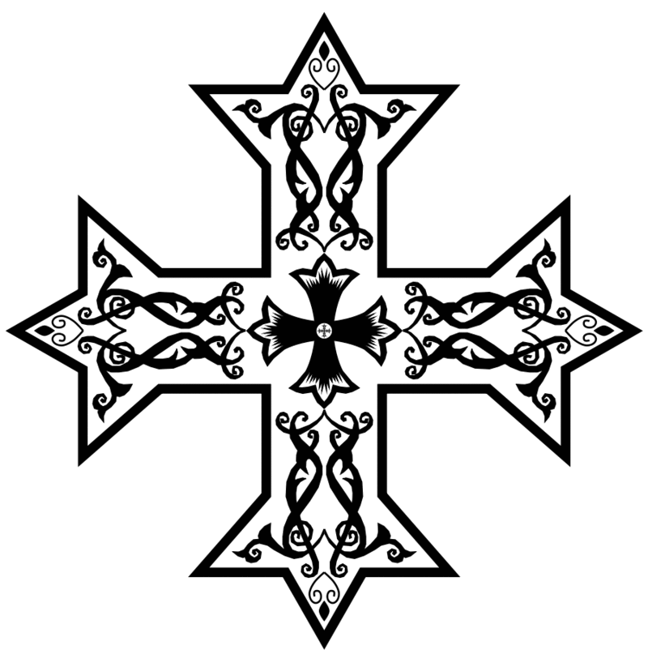
2016 – 2017 Arepsaline School 3rd & 4th Grade Hymns
Gospel Response During Nayrouz
Praxis Response First Sunday of Kiahk
Shere ne Maria, tiche-rompi ethnesos, thee-etas-misi nan, emifnoti pi-Loghos.
Shere Ghabriel, pi-nishti en-arshe angelos, shere fee-etaf-he-shennofi, em-Maria ti-parthenos.
Eksmaro-ot alethos, nem Pekiot enagha-thos, nem pi-epnevma ethowab, je (akee) aksoti emmon. Nai nan.
Hail to you O Mary, the beautiful dove, who gave birth to, God the Word.
Hail to Gabriel, the great archangel, hail to the announcer, of the Virgin Mary.
Blessed are You indeed, with Your good Father, and the Holy Spirit, for You have come and saved us. Have mercy on us.

<ere ne Maria@ ][rompi e;necwc@ ;y`etacmici nan@ `m`Vnou] Pilogoc.
<ere Gabriyl@ pinis] `nar,yaggeloc@ ,ere vy`etafhisennoufi@ `mMaria }par;enoc.
`K`cmarwout `aly;wc@ nem Pekiwt `n`aga;oc@ nem Pi`pneuma e;ouab@ je ak`i akcw] `mmon. Nai nan.
Alleluia Alleluia Alleluia Alleluia, Bless the crown of the year with Your goodness O Lord.
This is He who is worthy of glory, with His Good Father, and the Holy Spirit, both now and forever.
Alleloia Alleloia Alleloia Alleloia, Esmoo e-pi-eklom ente-ti rompi, he-ten tek-met-ekhrestos Epshois.
Fai ere pi-o-oo er-eprepi naf, nem pefiot en-aghathos, nem pi-epnevma ethowab, ias-jen tino nem sha eneh.
Allylouia =a=l =a=l =a=l@ `cmou `epi`,lom `nte ]rompi@ hiten tekmet`,ryctoc `P=o=c.
Vai ere pi`wou er`prepinaf@ nem Pefiwt `n`aga;oc@ nem pi`Pneuma e;ouab@ icjen ]nou nem sa `eneh.

